## 450MM

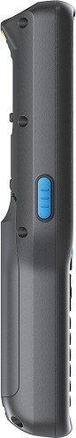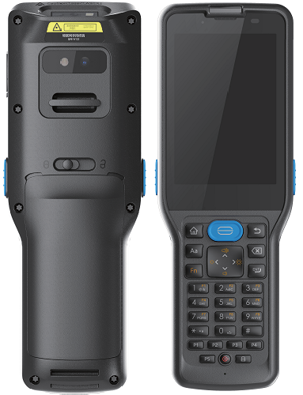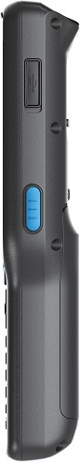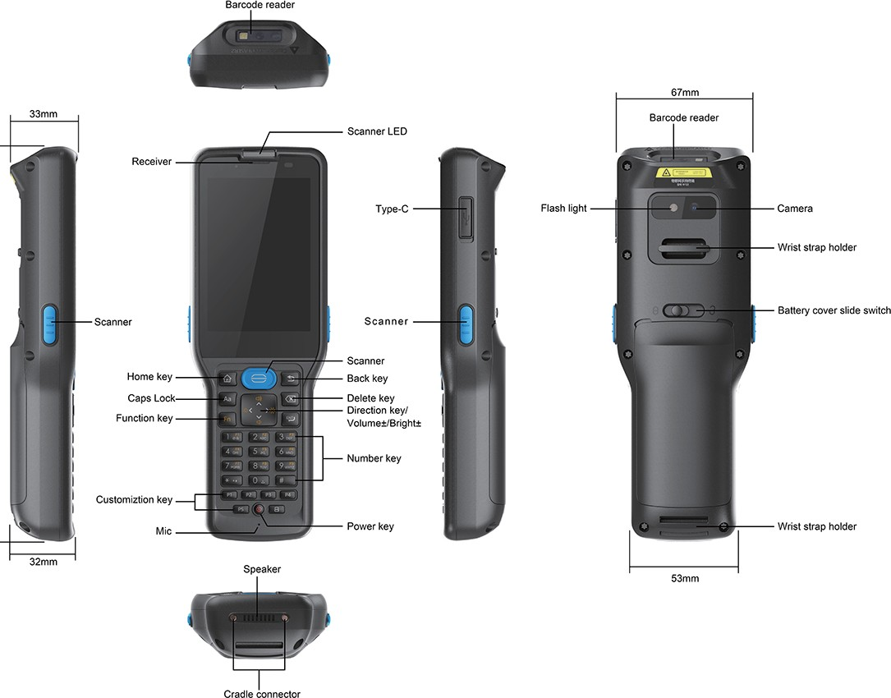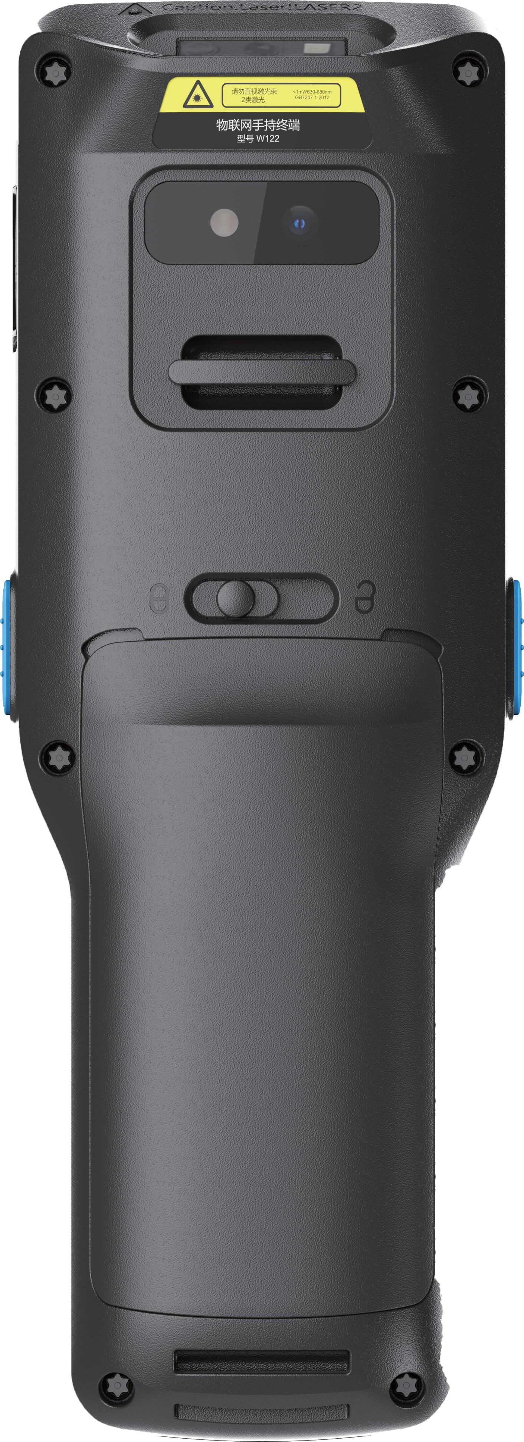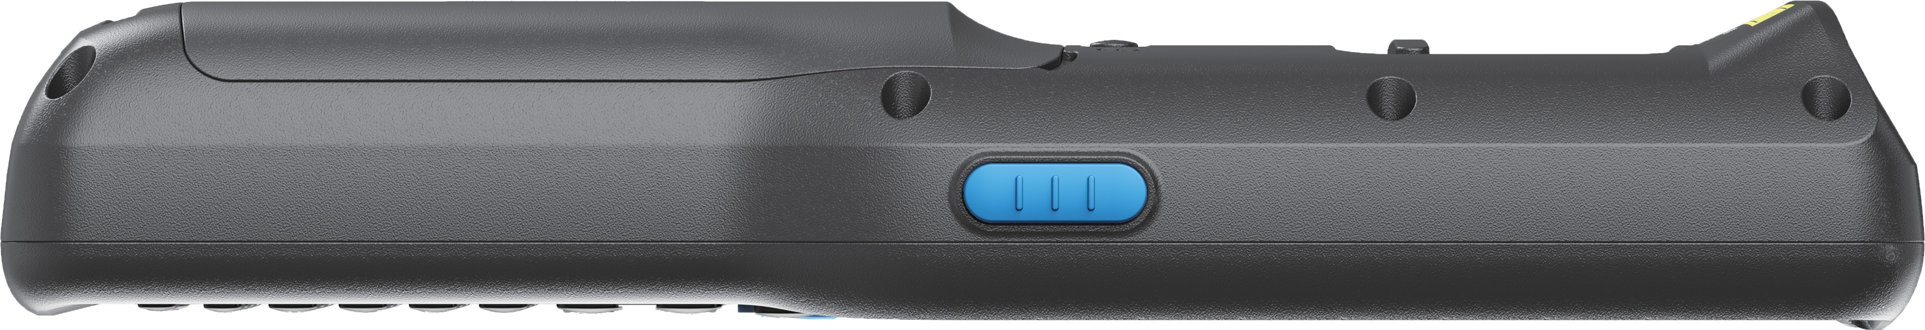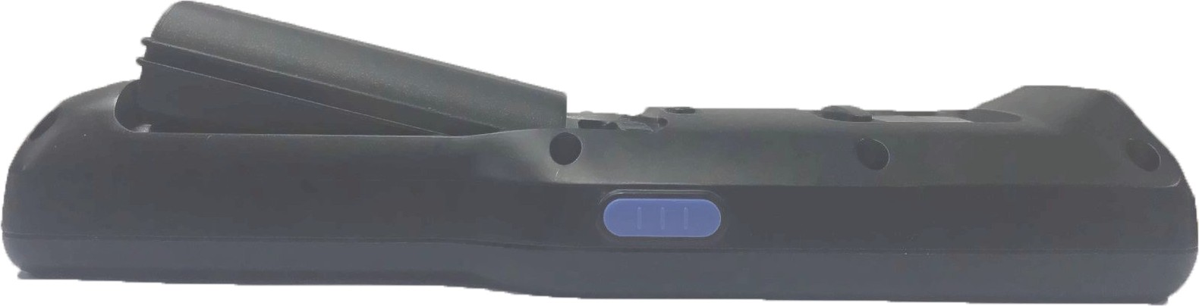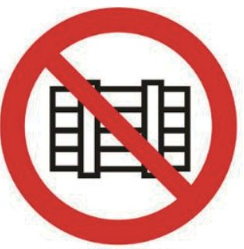

**User Manual**

**Handheld Terminal**

**Content**

Handheld Terminal appearance. 1

Parameter 2

**Handheld Terminal Appearance**

**Product index Product installation precautions**

|  |
| --- |
| **1, Disassemble and installation**  Pls do not disassemble or modify the parts of the equipment without authorization. If the equipment is damaged, the company will not be responsible for the warranty. |
| **2, External power supply**  Please use the power charger that comes with the device, otherwise the device may be damaged. |
| **3, Abnormal condition**  Keep away from fire. When abnormal smell, overheating or smoke is found, please turn off the battery immediately, remove the plug from the AC power outlet, and contact our after-sales service center. (Continue to use the  danger of fire and electric shock) |
| **4, Drop damage**  If the equipment is damaged due to falling on the ground, please turn off the power immediately and contact our after-sales service center. |
| **5, Storage Environment**  Please do not put the device in the place with a large amount of moisture or dust, so as to avoid electric leakage or fire;  Please do not place the device in direct sunlight. |

|  |  |  |
| --- | --- | --- |
| **Function** | | **Specification** |
| Name | | Handheld Terminal |
| OS | | Android 12 |
| CPU | | MTK6761, 4*A53 2.0 GHZ |
| Network Band | | 4G/3G/2G |
| Screen | Size | 3.5 inches |
| Direction | Vertical |
| Resolution | 320*480 |
| Touch screen | Type | Capacitance 5 point |
| Button | | Power button, Scan button, Num  button |
| Communication | Wi-Fi | 802.11 a/b/g/n/ac 2.4/5GHz |
| BT | BT5.0 |
| NFC | 13.56Mhz |
| GPS | Support |
| Scanning | 2D | Optional |
| Battery | Standard  battery | 5200mah |

#### Remove and install the battery cover.

**Important Note:** Please follow the instructions in the User's Guide to use the handheld terminal.

#### Remove the battery.

136MM

Handheld Terminal

#### Install the battery.

**Important Notes**

the battery should be loaded and removed according to

the instructions in the User's Guide

to avoid unnecessary damage to the body or battery

##### Step1:

**Install SIM, SD card.**

Notes for product installation. 2

Remove and install the batter cover 3，4

Install SIM card and memory card. 5

Product use precautions. 5

Battery use precautions. 6

NFC. 6

Frequently asked questions. 7

Notes. 8

Please read the instruction carefully before use.

#### Product use precautions

1.Please keep the scanning and camera window

lenses clean. When wiping, please use soft cotton.

1

#### Battery use precautions

1

1.It is recommended that you charge the battery before you start using the product. In general, the

6.There is a battery level indicator in the

2

**FAQ**

1. In the process of mobile wireless communication, the method of processing data transmission failure

##### Step 1:

Move the battery cover lock to the unlock position.

#### Caution!

##### Step3:

Remove the battery.

### 3

##### Step 2:

Open the battery cover as shown in the picture.

Keep the device away from vases,

Insert the battery.

##### Step2:

Close the battery cover.

After locking the battery cover, move

the battery cover lock to the locked position

* 1. Before insert SIM Card, please confirm that the power supply of this product has been turned off.
  2. Remove the battery cover and battery.
  3. Insert the TF card into the card holder according to the direction shown in the machine icon (the same with SIM card).
  4. Put the battery back until it is fixed.
  5. Put the battery cover back on.

cloth or lens paper to wipe. Do not use cleaning.

agent or solvent to scrub the scanning and camera window lenses.

1. Do not touch the abrasive material to the scanning and camera window lenses to avoid wearing the scanning and camera window lenses, which will affect the reading effect.
2. Abrupt changes in the ambient temperature may cause condensation on the device casing. In this state, the operating device may malfunction. Please take care to avoid condensation. If the device case is dew condensation, please wait until the device is dry.
3. Please read the barcode in the correct way: after the product software controls or manually touches the scan trigger button to trigger the scan engine, adjust the angle of the product and the barcode, or the distance between the two (the optimal distance is 10 - 15cm), Let the beam width is larger than the width of the bar code to obtain the best reading effect.

new battery will not perform optimally after several cycles of full charge and discharge.

1. The battery can be charged and discharged hundreds of times, but it will eventually be unusable. When the battery life is significantly shortened, replace the battery with a new one.
2. Only use the battery approved by the company, and only use the charger approved by the company to charge the battery.
3. When the charger is not used, please turn off the power. Do not connect the battery to the charger for more than a week, as overcharging will shorten the battery life. If the fully charged battery is left unused, the battery itself will also discharge.
4. If the temperature is too high or too low, it will affect the battery charging. You need to cool or warm up before charging the battery.

upper right corner ofthe product screen.

When the battery is full, it indicates that the battery is fully charged When the battery indicator is displayed as one cell, it indicates that the battery is very low. The screen will prompt "The battery is low, please charge it in time". Please save the existing work as soon as possible and charge it in time.

7.When the battery indicator icon shows zero, the power of this product is seriously insufficient. The screen will prompt "The

battery is insufficient, please charge it in

time", then automatically shut down.

#### NFC

This function hardware is in the rear case, so when using this function, please attach the NFC tag to the back cover of terminal for identification

Please follow the steps below to troubleshoot:

1 ) Check if the signal icon of the mobile wireless communication in the upper left corner of the product screen has a signal. If there is no signal icon for moving the wireless communication, the SIM card may not be installed. Please remove the SIM card and

reinstall it to ensure that the SIM card can work normally. If the signal is below two grids, please send the data to the place where the signal is better. If the signal still fails to send, please refer to the next step.

2) Please confirm with the network operator (Mobile, Telecom or China Unicom) whether the SIM card of the machine is in arrears. If the SIM card balance is insufficient, please recharge the SIM card as soon as possible.

2.How to handle the product when it is charging

This is caused by excessive battery power, and the battery can.

Be turned on normally after charging for a period.

3.Scanning insensitive processing method

First, check if the barcode is flat, clear, and tidy. If the barcode is broken, please exit the scan code and perform manual operation directly; then, adjust the distance and angle of the scan; finally, check if the scan window is clean (dust and water drops). 4.The screen does not display the processing method

Check if it is turned on, or check if the battery is dead or in

This product batter y can only be charged with the

specified charger. Using other chargers may cause the batter y to heat up, explode, and catch fire. This product is only suitable for

areas with an altitude of 2000 meters and below.

If the product is hot or starts to emit smoke or emits odor, immediately turn off the power, unplug the power supply, remove the batter y, and contact our after-sales service center. If you continue to use it, it may cause fire and electric shock.

Do not attempt to disassemble or modify the batter y in any way, as this will damage the batter y and cause malfunction or damage to the main unit.

Do not touch internal high voltage components or components. Doing so may cause electric shock.

Never look directly at the laser beam, as it will seriously damage your eyes.

flowerpots, porcelain cups, glasses and

other water containers, and metal. Water

and metal

entering the product may cause fire and electric shock and cause damage to the product.

4 5 6 poor contacts. 7 . 8

# 1，铜版纸70g

2，双面印刷，4折

3，3mm出血线